**POWER BI PROJECT 1 (DETAILED DOCUMENTATION)**

**AIM-**

To analyse the data of COVID-19 in detail on vaccinated people by year and country.

**INTRODUCTION-**

The COVID-19 pandemic has been an unprecedented global health crisis that has profoundly impacted societies, economies, and healthcare systems worldwide. As nations grapple with the evolving nature of the virus and its variants, understanding the trends and patterns of COVID-19 infections, hospitalizations, and mortality rates has become crucial for effective public health policymaking and resource allocation. In this analysis, we delve into the trends of COVID-19, examining factors such as vaccination efforts, healthcare capacity, and public health interventions to gain insights into the trajectory of the pandemic and inform strategic responses. Through rigorous data analysis and interpretation, we aim to shed light on the dynamic nature of COVID-19 and provide valuable insights for mitigating its impact on global health and well-being.

**PROBLEM STATEMENT-**

* What are the percentage of people vaccinated in all countries from 2020-22?
* What are the approx. daily vaccinations taken in each month in a particular year?
* Which vaccines has been used in every country tell specifically?
* Mention the sources from which information has been taken.

**METHODOLOGY-**

* In conducting a COVID-19 trend analysis, a robust methodology is essential to ensure the accuracy and reliability of findings. Initially, comprehensive datasets from reputable sources such as government health agencies, international organizations, and research institutions are collected. These datasets typically include information on daily or weekly reported cases, hospitalizations, deaths, testing rates, vaccination coverage, and demographic characteristics of affected populations.
* Once the data is collected, we conduct descriptive statistical analysis to identify key trends and patterns over time. This involves calculating summary statistics such as mean, median, standard deviation, and percentiles to understand the distribution of COVID-19 cases and outcomes. Additionally, we utilize time-series analysis techniques to examine the temporal evolution of the pandemic, including identifying peaks, troughs, and seasonal variations.
* In parallel with quantitative analysis, we leverage data visualization techniques to communicate our findings effectively. We create visualizations such as line graphs to illustrate trends in case counts and pie charts to represent the distribution of COVID-19 outcomes (e.g., percentage of cases by country).
* Furthermore, we compile our analysis and visualizations into a comprehensive report that provides insights into the dynamics of the pandemic. The report includes interpretations of the data, key findings, implications for public health policy, and recommendations for future research or intervention strategies.

**ANALYSIS-**

* First, we created a slicer to distinguish the whole information year wise, by creating a date hierarchy. Through this we can analyse how many countries have started the vaccination process in 2020, 2021 and 2022. Through this we get to know that vaccination process started in 2020 from two counties USA and Germany which started worldwide from 2021.

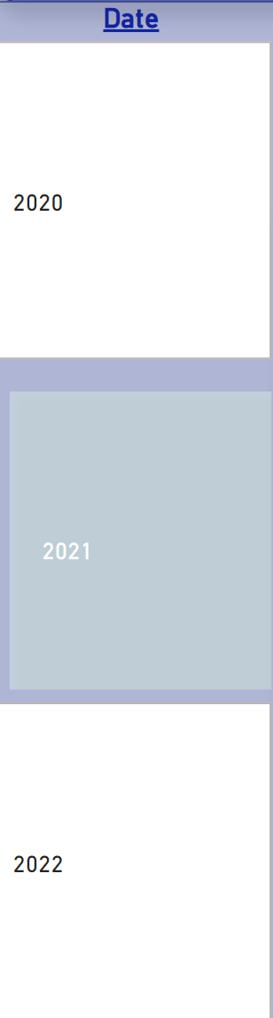

* Then just to summarize at the start of the report I created two face cards to tell how many countries information is recorded in the report and how many vaccinations have been occurred in these years is summarized.

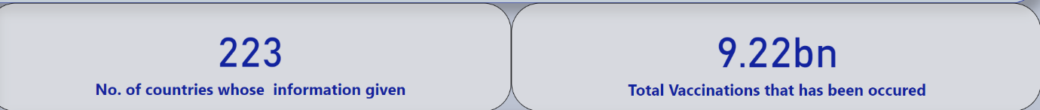

* Then I created a pie chart to tell the countries that has been vaccinated in that year and its percentage of vaccinations. In the pie chart below I have told the information about the year 2021. 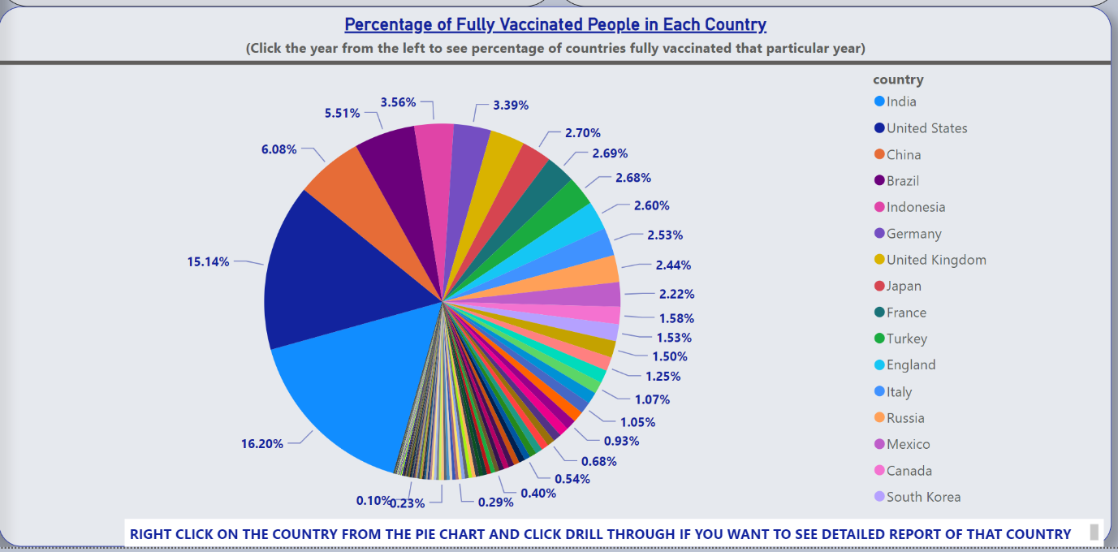
* In next page I created a table to see vaccines used in each country, source from where we have got the information and a line chart to see the daily vaccinations getting in each country.
* I created a drill through page 1 that is named as “Home Page” to another page which I renamed as “Detailed Report of the country” by adding countries in the field so that whenever we right click in any country in pie chart, we get the table and line chart of that country and year selected from the slicer.
* In this page you can see a detailed report on approx. daily vaccinations in the country selected, vaccines used in the country USA, source from where we have got the information and a line chart to see the daily vaccinations getting in that country in the year 2021 as selected.

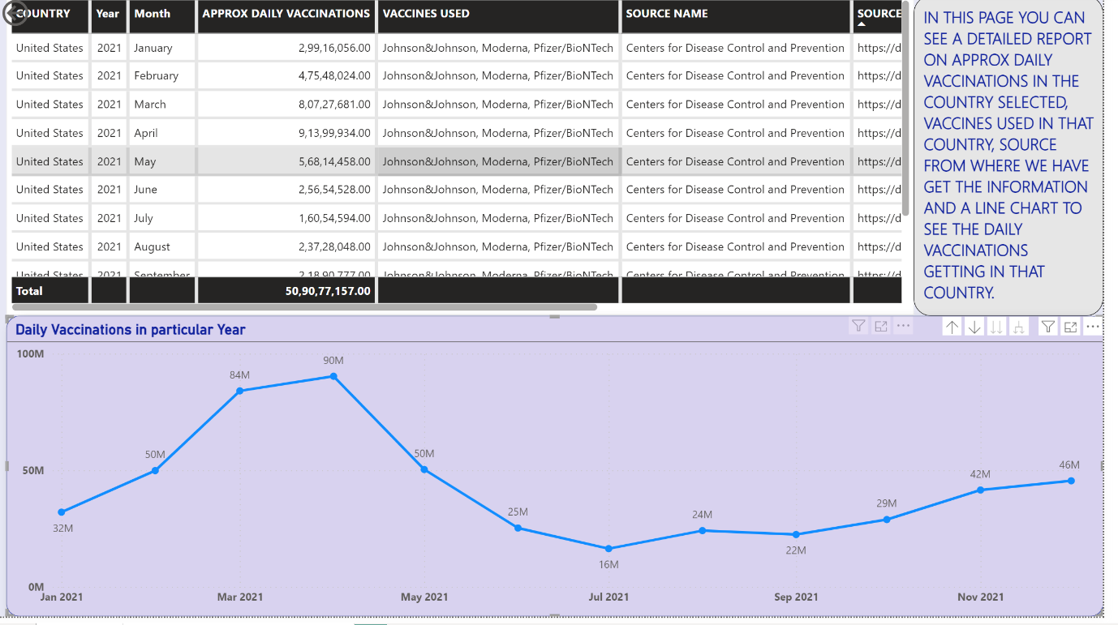

**INSIGHTS-**

* Our COVID-19 trend analysis, enriched with visualizations such as pie charts and detailed reports, has yielded profound insights into the dynamics of the pandemic. One key insight gleaned from our analysis is the disproportionate impact of COVID-19 across different demographic groups. Through pie charts depicting the distribution of vaccines used in different countries, we uncovered that country with more populations tend to experience higher rates of severe illness and mortality, emphasizing the urgency of prioritizing vaccination efforts and protective measures for vulnerable groups to country like USA.
* Moreover, our analysis revealed the evolving nature of the pandemic, with trends in case counts, positivity rates, and vaccination coverage fluctuating over time. By synthesizing these trends into actionable insights, our analysis provides stakeholders with valuable information to guide decision-making and policy formulation, ultimately contributing to more effective pandemic response efforts.

**RECOMMENDATIONS**-

* Our analysis underscores the importance of prioritizing vaccination efforts, particularly among vulnerable populations such as the elderly and those with underlying health conditions. Governments and healthcare authorities should implement targeted vaccination campaigns to ensure equitable access to vaccines and achieve high levels of immunization coverage.
* Operations can be conducted across different categories. To enhance the precision and value of data analysis, it is crucial to guarantee that the datasets utilized are of top-notch quality and are well-maintained and structured.
* Advanced and financially stable nations ought to assist less developed and developing countries in enhancing the vaccination coverage of their populations.

**CONCLUSIONS**

In conclusion, our COVID-19 trend analysis has provided valuable insights into the trajectory of the pandemic and the effectiveness of various response strategies. Through rigorous data collection, analysis, and visualization techniques, we have gained a deeper understanding of the evolving nature of the virus, its impact on different demographic groups and regions, and the dynamics of vaccination efforts.

Our analysis has highlighted the disproportionate burden of COVID-19 on vulnerable populations, emphasizing the need for targeted interventions to address disparities in infection rates, healthcare access, and vaccine uptake. Additionally, we have identified hotspots of transmission and fluctuations in healthcare resource utilization, underscoring the importance of adaptive response measures to ensure adequate capacity and quality care delivery.

Furthermore, our analysis has underscored the critical role of vaccination in controlling the spread of COVID-19 and mitigating its impact on public health and society. By visualizing vaccination coverage rates, tracking vaccine effectiveness, and monitoring adverse events, we have provided stakeholders with actionable insights to guide vaccination campaigns, resource allocation decisions, and public health policy formulation.

Moving forward, it is imperative that we continue to monitor COVID-19 trends closely, adapt our response strategies based on evolving data and evidence, and prioritize collaboration and coordination among governments, healthcare organizations, and international stakeholders. By leveraging the lessons learned from our trend analysis and remaining vigilant in our efforts to combat the pandemic, we can work towards overcoming this global crisis and building a safer and healthier future for all.